- Create one folder.
- Open Git Bash and go to that folder.
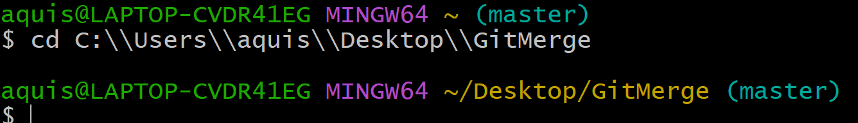

- Initialize git

- Check status
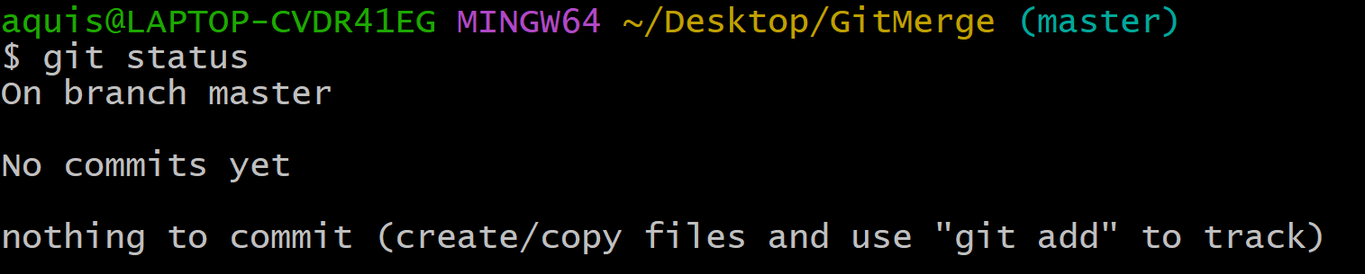

- Create on text file using touch command or vim editor.
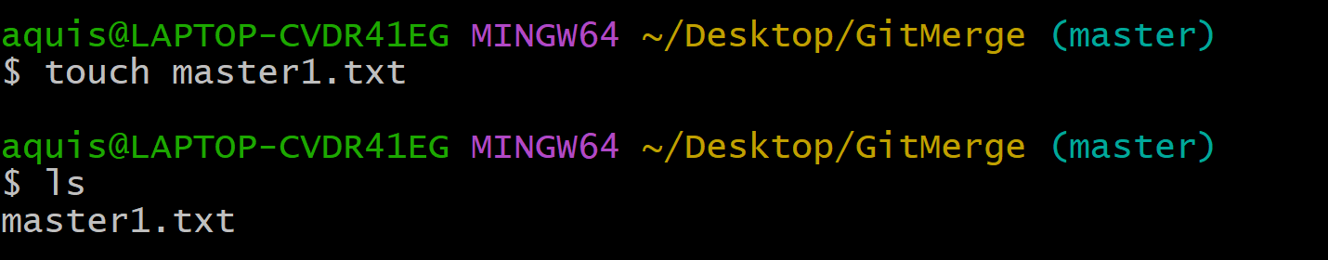

- Check status
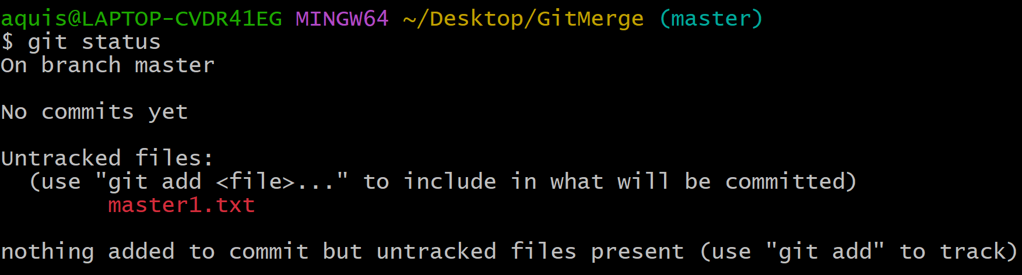

- Go to vim and add some content to file.
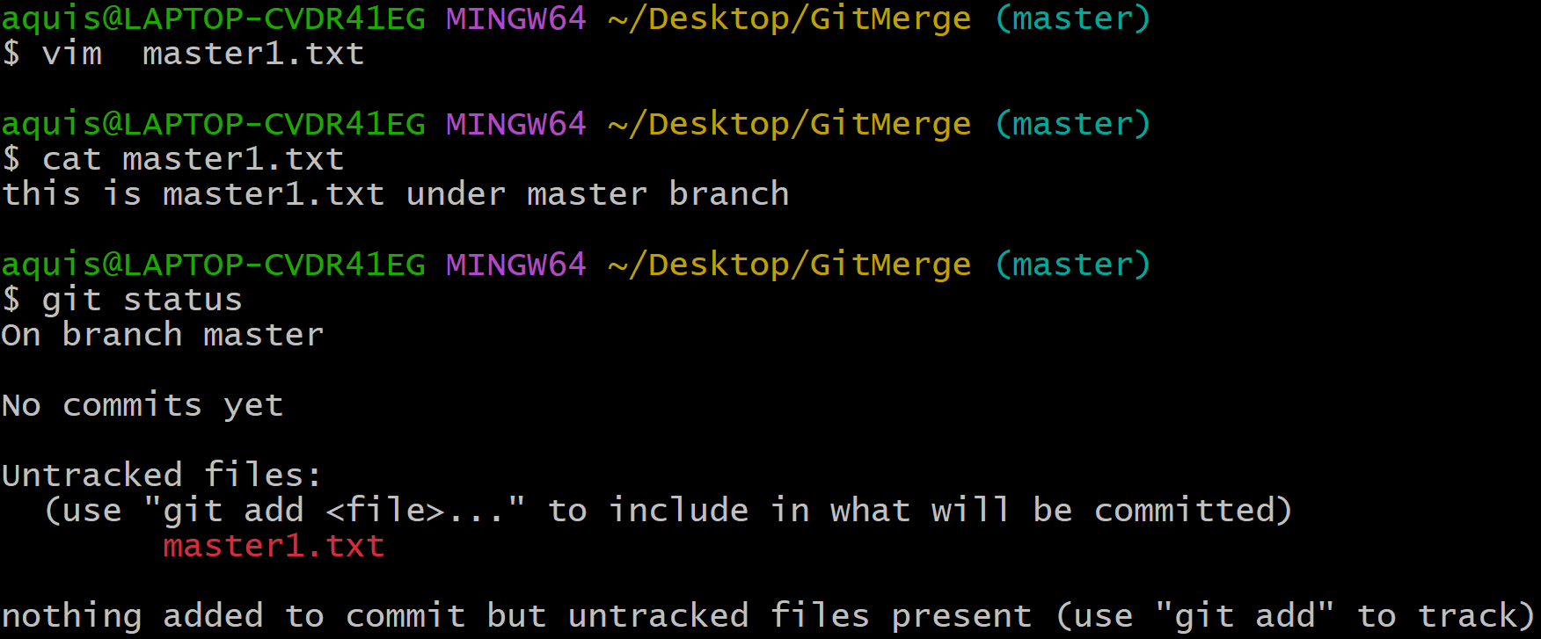
- Convert the file from modified state to staged state and check the status.
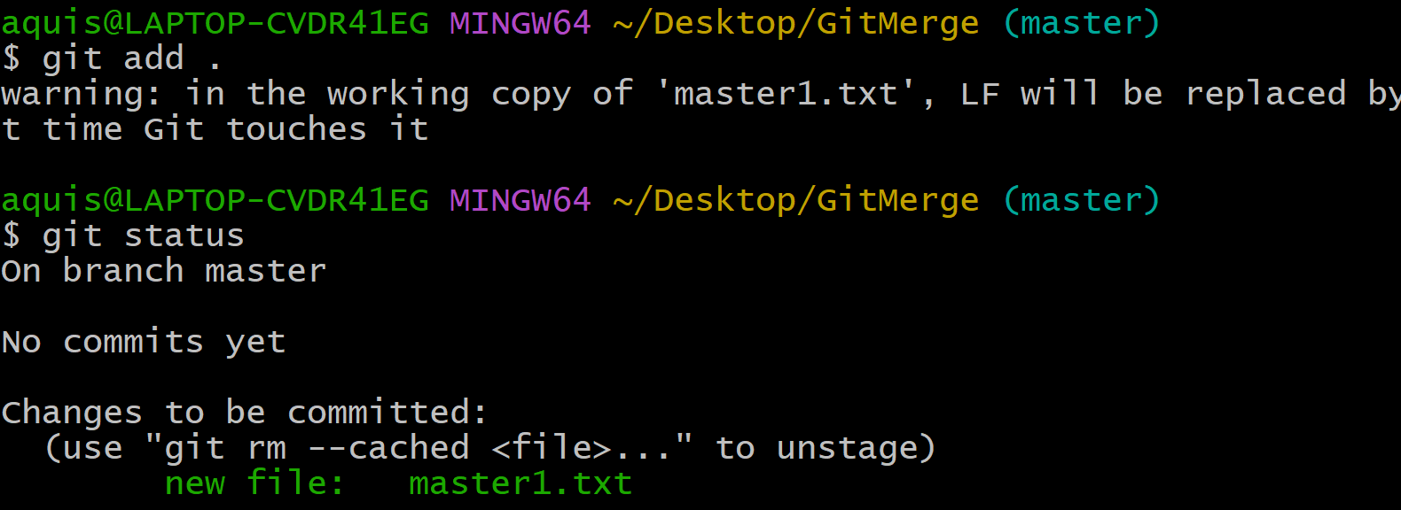

- Perform commit operation.
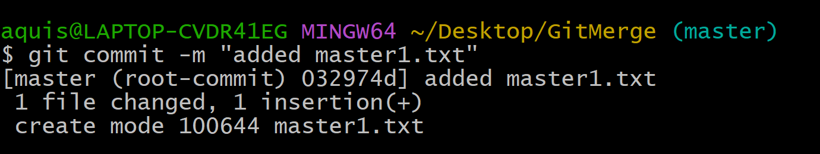

- Now, Create new branch say “hiray”.
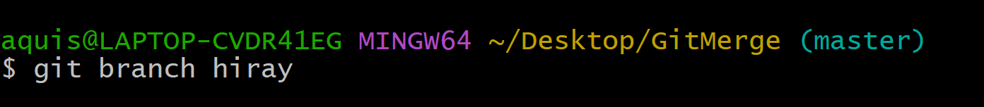

- Switch to hiray branch by using a command → checkout
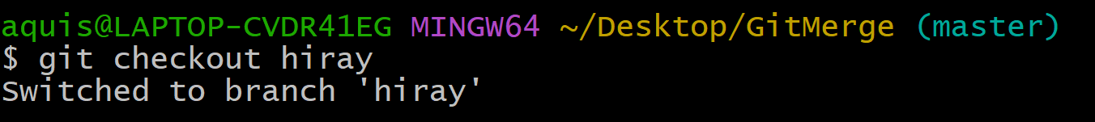

- Check status
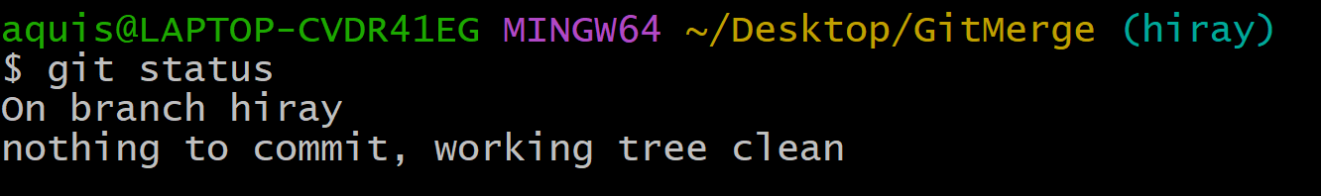

- Create new text file as “hiray.txt” and check status.
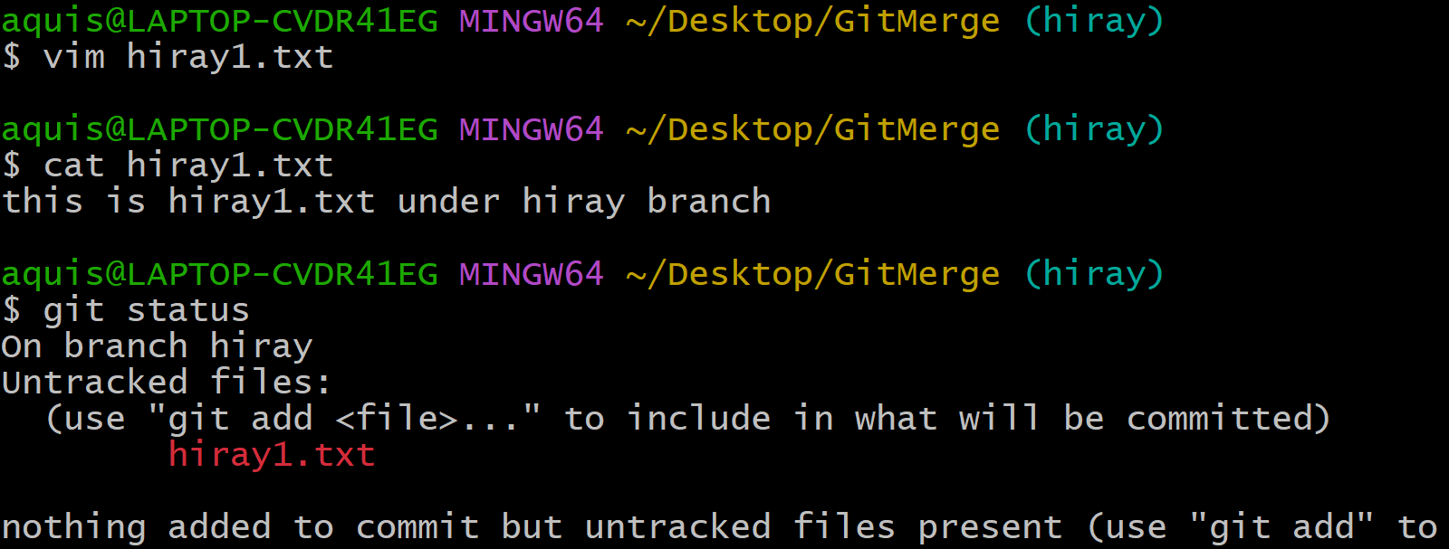
- Showing untracked file.

- Add the file, perform commit operation and check the status.
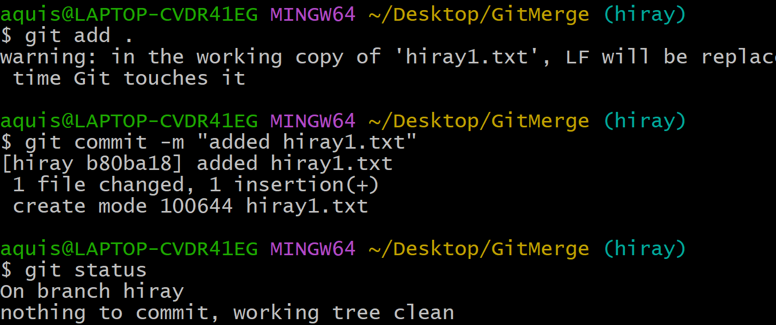
- You can see both files (master1.txt and hiray1.txt ) in GitMerge folder.
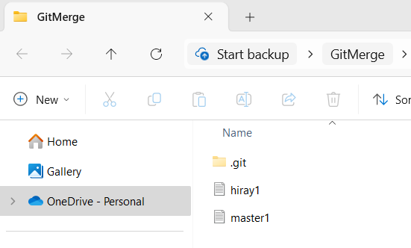

- Check log → (it will show two commits)
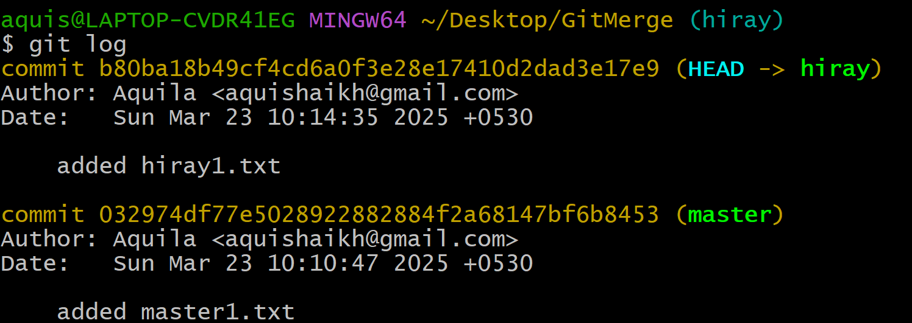

- Switch to Master branch.
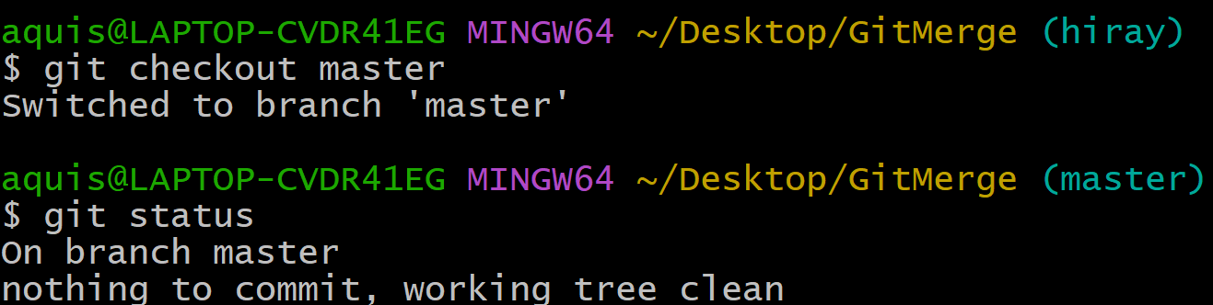

- If you switch to master branch, you won’t be able to see “hiray1.txt” in the folder.
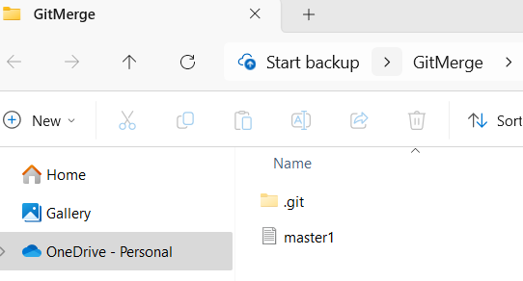

- Let’s create one more text file at master branch
- Perform add and commit and check log (you will be able to see two commits at master branch)
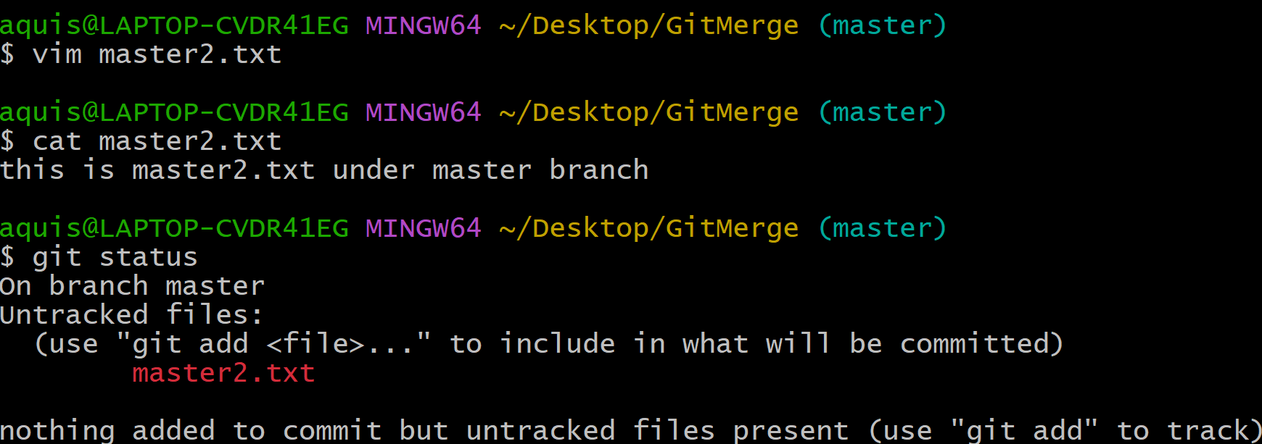
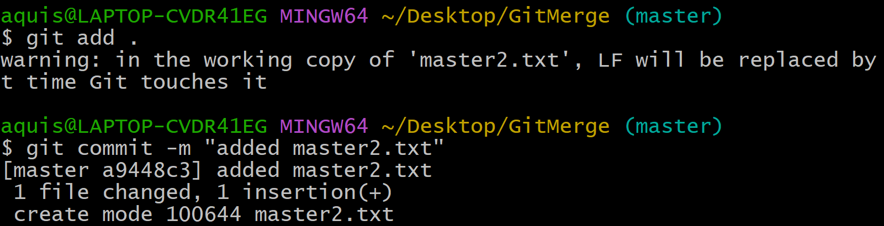

- Suppose at this point the changes have happened at master branch are relevant to hiray branch
- And we want to get all changes from master branch to hiray branch.
- There are two options: Git merge and Git rebase
- Checkout to hiray branch and perform merge operation.
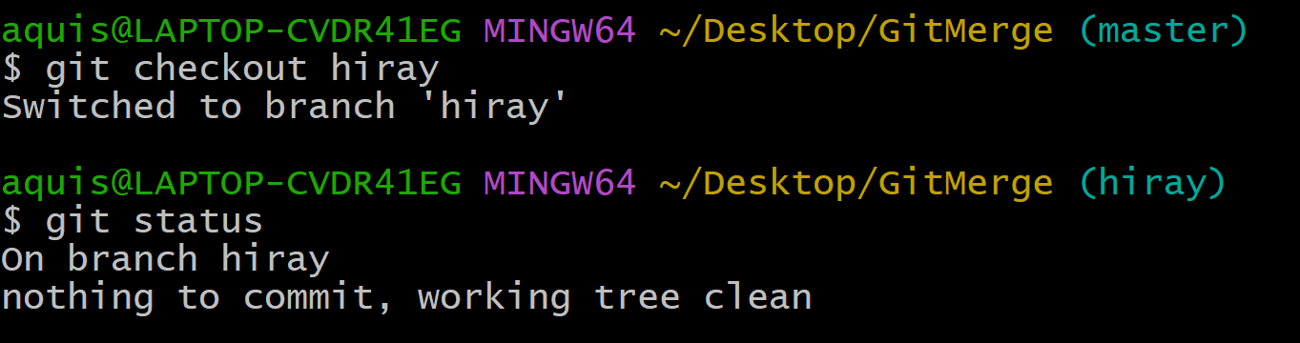
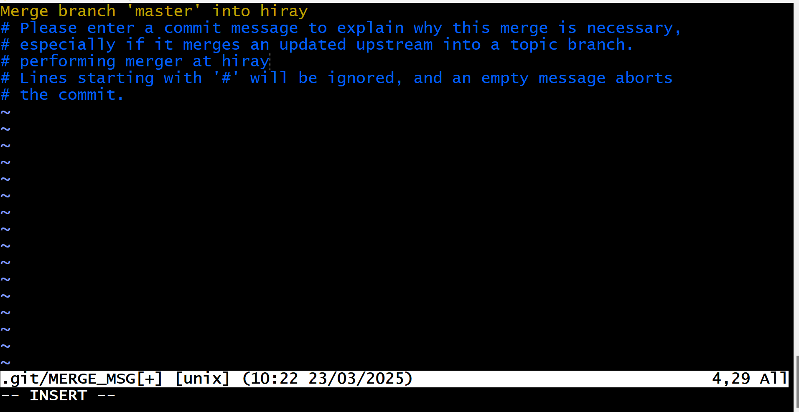
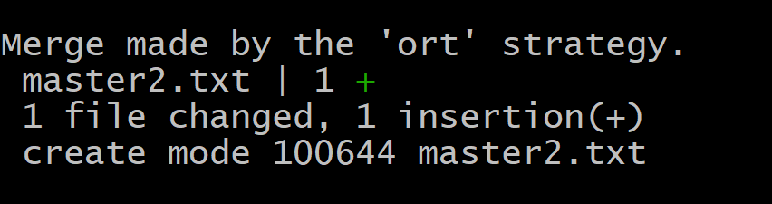

- Check log
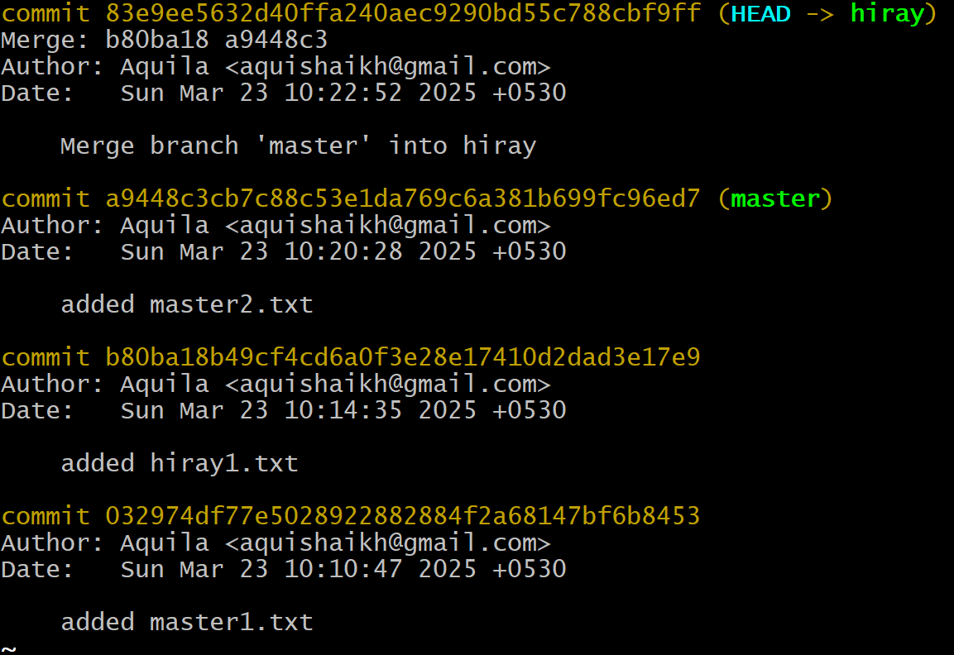
- Check GitMerge folder→ you can see all 3 files.
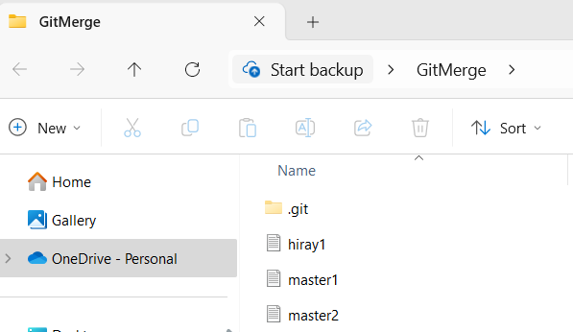

Git Rebase:
- Create on folder say “GitRbase”.
- Open Git bash, go to that folder and initialize git.
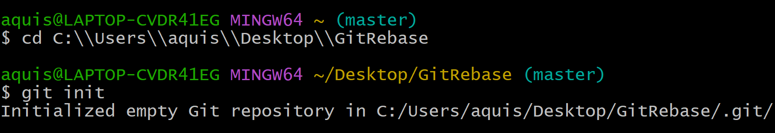

- Check status
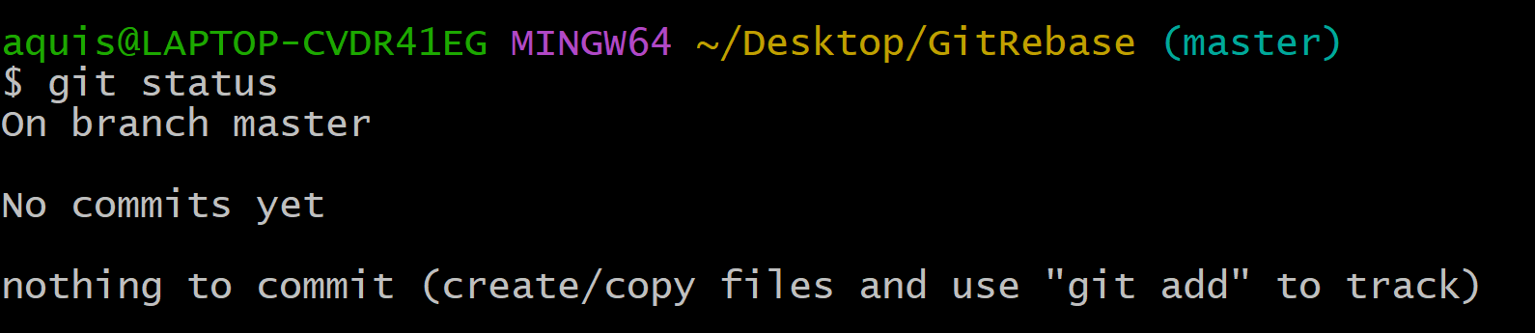

- Create m1.txt at master branch, add it and perform commit.
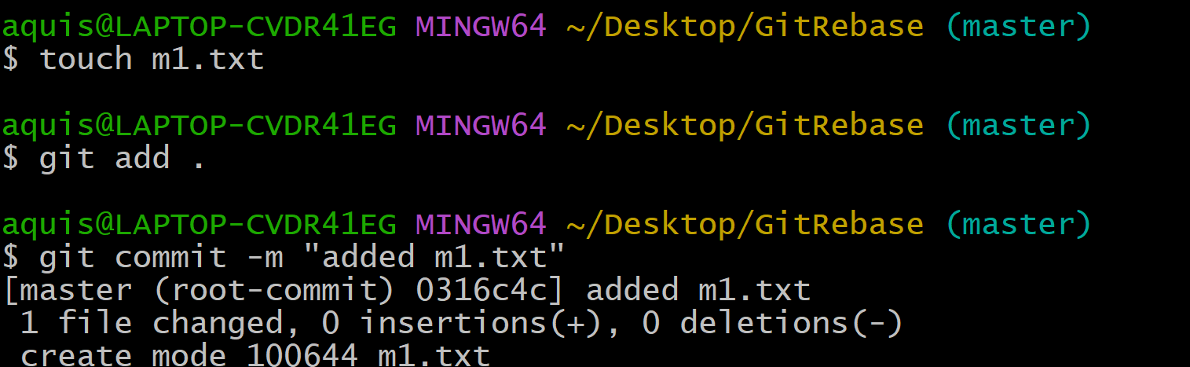

- Check log (it will show one commit for m1.txt)
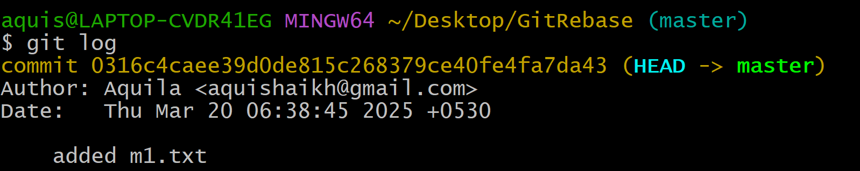

- Create new branch hiray and switch to hiray branch.
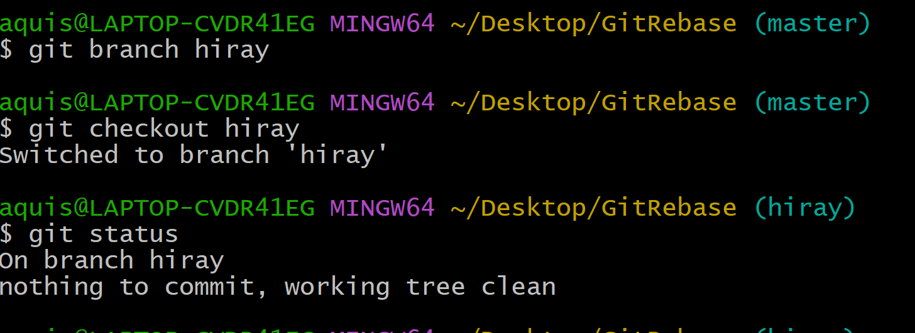
- Check log (showing only one commit → m1.txt)
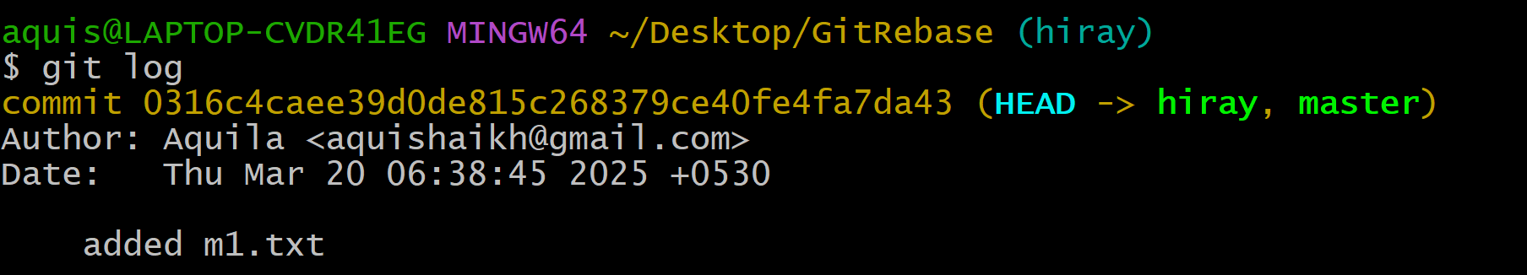

- At hiray branch, we will create new file say (h1.txt)→ add it and perform commit operation.
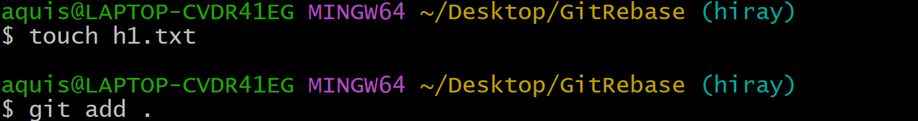
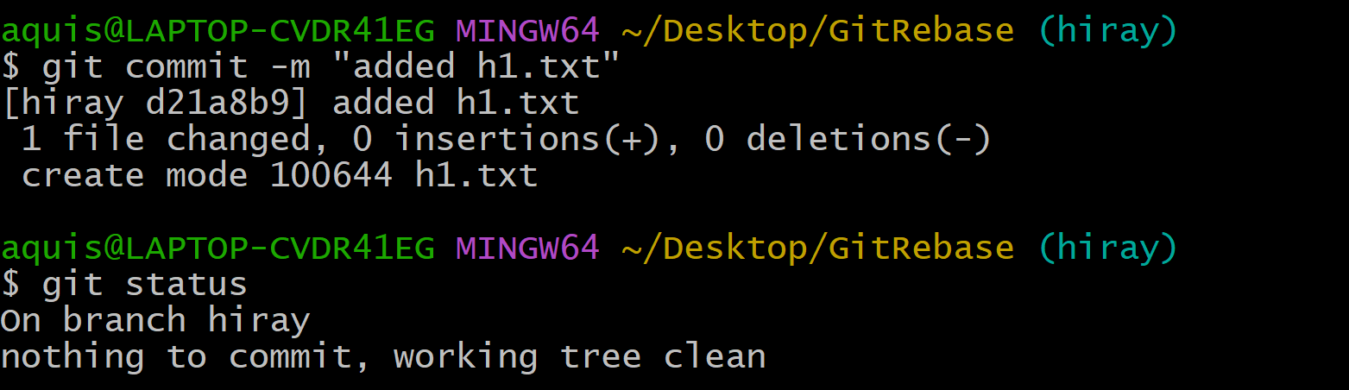

- Check status
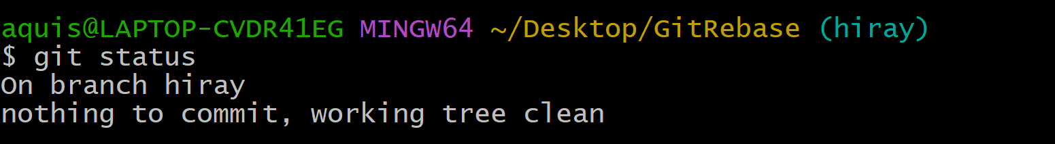

- Check log (Showing 2 commits)
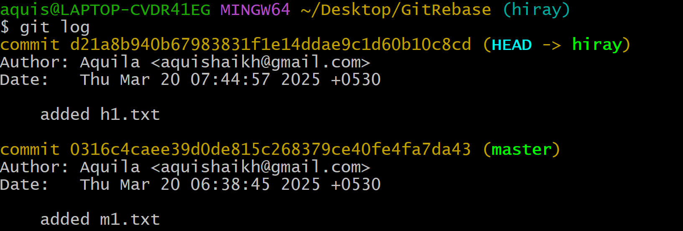

- Switch to Master branch
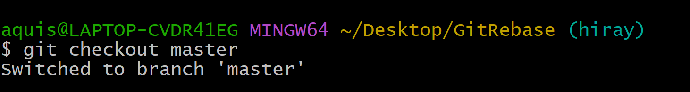
- As we swtich to master → we can see h1.txt is not there in the folder.
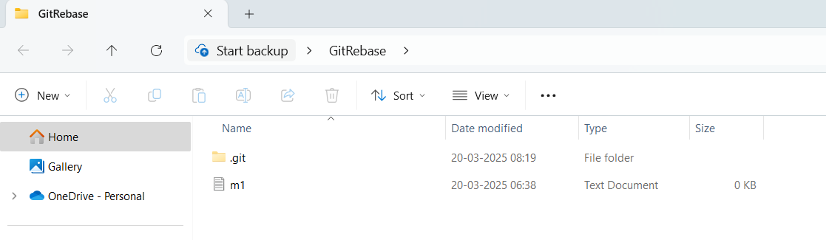

- Now in master branch, we will create m2.txt, add it and perform commit operation.
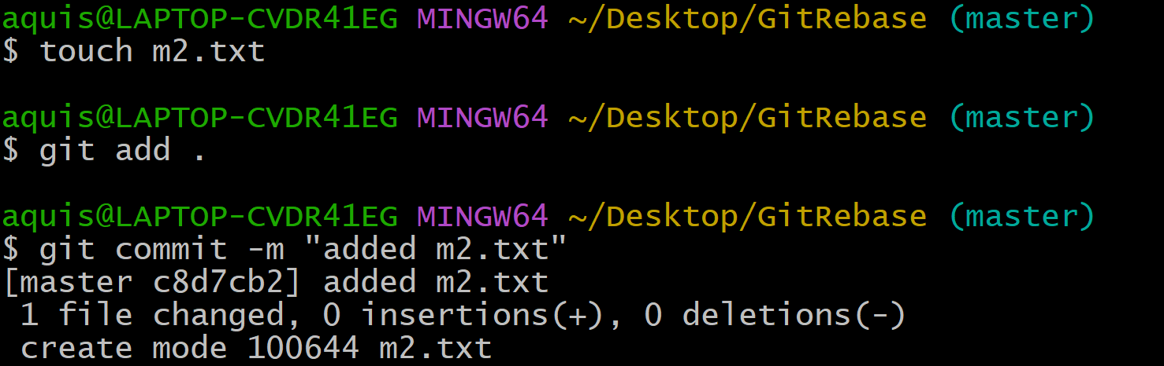

- Check log (showing m1.txt and m2.txt)
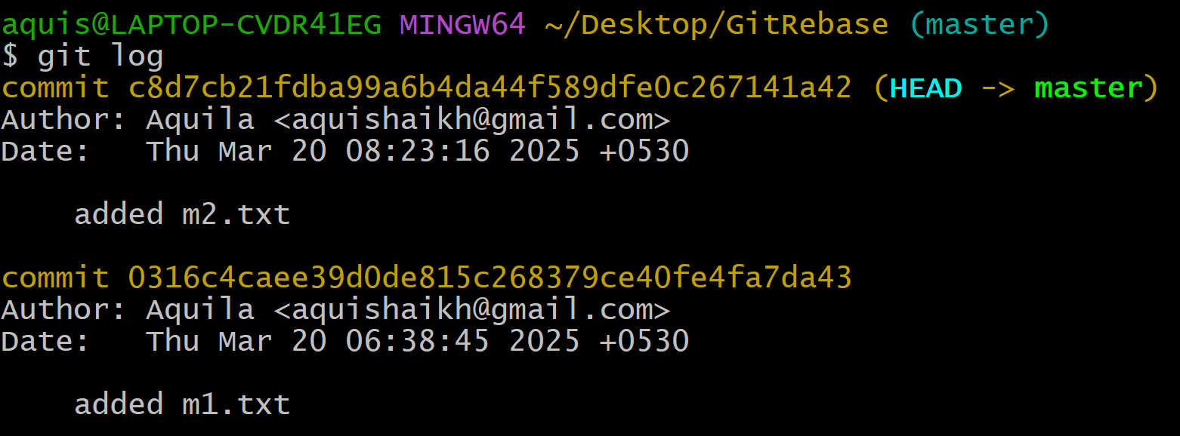

- Switch to hiray branch
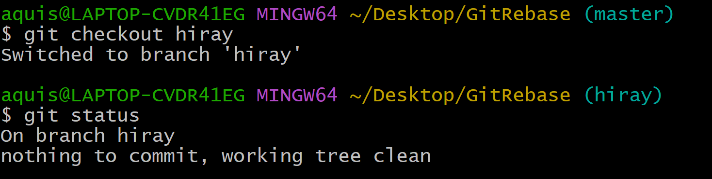

- We are on hiray branch→ it is having m1.txt and h1.txt
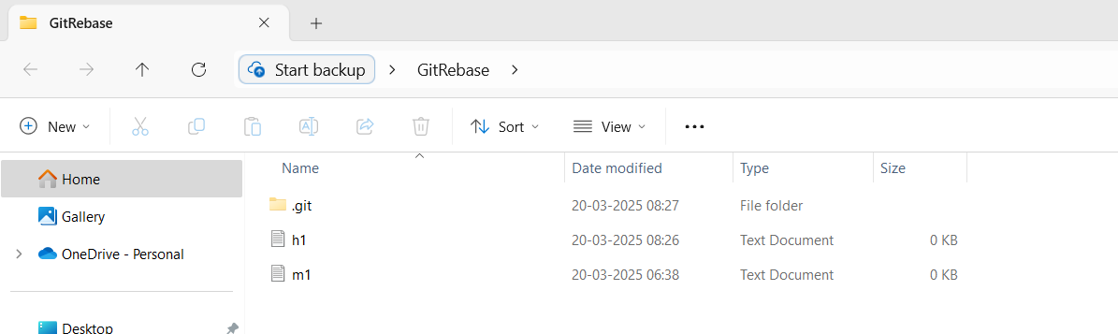

- Perform “rebase”
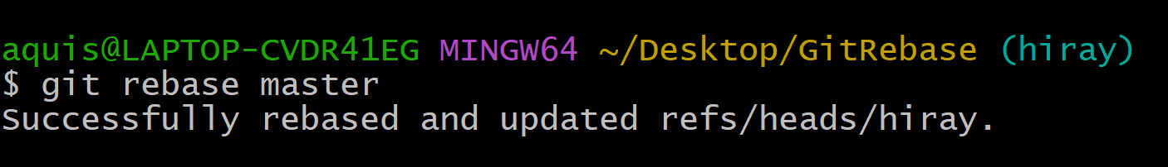

- As soon as we perform rebase operation→ we will be able to see m2.txt in out folder.
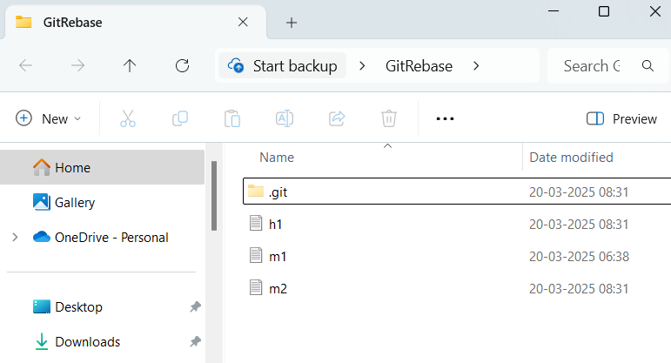

- Check log
